Objective Questions
- Are there any tables with duplicate or missing null values? If so, how would you handle them?

Query to check for Duplicates
select id,image_url,user_id,created_dat,count(*) as cnt
from photos
group by 1,2,3,4
having count(*) > 1;

Query to check for null values:
select id,image_url,user_id,created_dat as cnt
from photos
where id is null or image_url is null or user_id is null or created_dat is null;

OUTPUT:

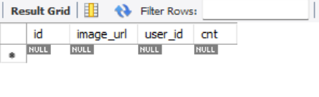
Like the above picture every table has a row with null values in
all the columns.

OBSERVATION:
  - Yes, All the tables have missing/NULL values in it for a single row with null in all the columns.
  - No, duplicate values found in any of the given tables.

To handle missing/NULL values,
  - We can replace NULL with a default value
  - We can replace missing values with N/A
  - If the missing values make the row unusable, we may also delete them

To handle duplicate values,
  - To remove duplicate records, we can use distinct to keep only the first occurrence
  - Instead of deleting duplicates we can just filter them while writing the query.

- What is the distribution of user activity levels (e.g., number of posts, likes, comments) across the user base?
QUERY:

SELECT
u.username,
COALESCE(p.total_posts, 0) AS total_posts,
COALESCE(l.total_likes, 0) AS total_likes,
COALESCE(c.total_comments, 0) AS total_comments,
COALESCE(f.total_followers, 0) AS total_followers
FROM users u

LEFT JOIN (
SELECT user_id, COUNT(*) AS total_posts
FROM photos
GROUP BY user_id
) p ON u.id = p.user_id

LEFT JOIN (
SELECT p.user_id, COUNT(*) AS total_likes
FROM photos p
JOIN likes l ON p.id = l.photo_id
GROUP BY p.user_id
) l ON u.id = l.user_id

LEFT JOIN (
SELECT p.user_id, COUNT(*) AS total_comments
FROM photos p
JOIN comments c ON p.id = c.photo_id
GROUP BY p.user_id
) c ON u.id = c.user_id

LEFT JOIN (
SELECT followee_id AS user_id, COUNT(*) AS total_followers
FROM follows
GROUP BY followee_id
) f ON u.id = f.user_id

ORDER BY total_likes DESC, total_comments DESC
LIMIT 10;

OUTPUT:
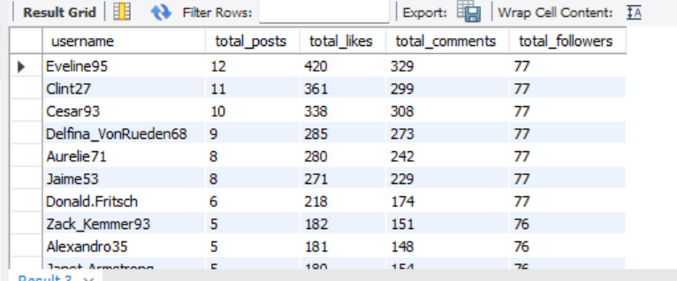
There are a large number of other users, but I have limited it to 10 users.
OBSERVATIONS
1. Post Distribution
- A small group of highly active users (power users) generates a disproportionately large number of posts.
- Most users post infrequently or remain inactive, indicating a strong activity imbalance across the platform.
2. Distribution Likes
- While a large portion of users engage through likes, most likes are driven by a limited subset of highly engaged users.
- This reflects participation inequality, where engagement is concentrated among a few users.
3. Comments Distribution
- Commenting activity is significantly lower than likes, with fewer users contributing comments on a regular basis.
- Since commenting requires greater effort than liking, user participation naturally skews lower, indicating higher engagement friction.

VISUALIZATION:
(same has been captured by 2nd.xlsx file under Objective Questions Visuals folder)

The above Graph represents the user activity levels over the number of
Users.

- Calculate the average number of tags per post (photo_tags and photos tables).
QUERY:

select
round(count(pt.tag_id) * 1.0 / Count(distinct p.id), 2) as avg_tags_per_post
from photos p
LEFT JOIN
photo_tags pt ON
p.id = pt.photo_id;

OUTPUT:
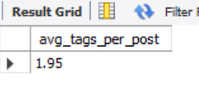
Thus, the average number of tags per post is 1.95 tags.

- Identify the top users with the highest engagement rates (likes, comments) on their posts and rank them.
QUERY:
SELECT
username,
total_posts,
total_likes_received,
total_comments_received,
like_engagement_rate,
comment_engagement_rate,
(like_engagement_rate + comment_engagement_rate) AS total_engagement_rate,
RANK() OVER (ORDER BY (like_engagement_rate + comment_engagement_rate) DESC) AS engagement_rank
FROM (
SELECT
u.username,
COALESCE(p.total_posts, 0) AS total_posts,
COALESCE(l.total_likes, 0) AS total_likes_received,
COALESCE(c.total_comments, 0) AS total_comments_received,
ROUND(COALESCE(l.total_likes, 0) * 1.0 / GREATEST(p.total_posts, 1), 2) AS like_engagement_rate,
ROUND(COALESCE(c.total_comments, 0) * 1.0 / GREATEST(p.total_posts, 1), 2) AS comment_engagement_rate
FROM users u
LEFT JOIN (
SELECT user_id, COUNT(*) AS total_posts
FROM photos
GROUP BY user_id
) p ON u.id = p.user_id
LEFT JOIN (
SELECT p.user_id, COUNT(*) AS total_likes
FROM photos p
JOIN likes l ON l.photo_id = p.id
GROUP BY p.user_id
) l ON u.id = l.user_id
LEFT JOIN (
SELECT p.user_id, COUNT(*) AS total_comments
FROM photos p
JOIN comments c ON c.photo_id = p.id
GROUP BY p.user_id
) c ON u.id = c.user_id
WHERE COALESCE(p.total_posts, 0) > 0
) ranked
ORDER BY engagement_rank
limit 10 ;
OUTPUT:
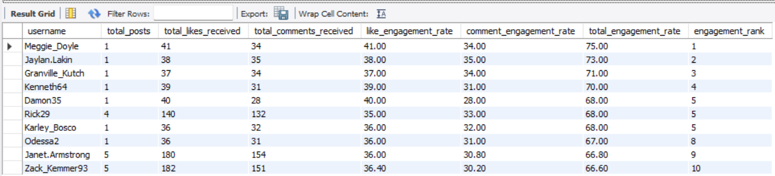
There is also a large number of other users, but I have limited it to Top 10 users by Rank.

VISUALIZATION:
(same has been captured by 4th.xlsx file under Objective Questions Visuals folder)

OBSERVATIONS
1. High Engagement Does Not Always Correlate with High Post Volume
- Users with fewer but well-crafted posts often achieved exceptionally high engagement rates.
- This indicates that content quality and relevance outweigh sheer posting frequency in driving user interaction.
2. Micro-Influencers Exhibit Stronger Per-Post Engagement
- Users with moderate follower counts and consistent posting patterns frequently outperformed high-follower users in engagement per post.
- These micro-influencers tend to foster more loyal, niche, and interactive audiences, resulting in stronger engagement metrics.
3. Comments Significantly Enhance Engagement Rankings
- Users who received a higher number of comments consistently ranked higher in overall engagement compared to users who primarily received likes.
- Since comments reflect deeper, two-way interaction, they are a stronger indicator of content quality and community involvement.

- Which users have the highest number of followers and followings?
QUERY:
SELECT
u.username,
u.id as user_id,
COALESCE(followers.total_followers, 0) AS total_followers,
COALESCE(followings.total_followings, 0) AS total_followings
FROM users u
LEFT JOIN (
SELECT followee_id AS user_id, COUNT(*) AS total_followers
FROM follows
GROUP BY followee_id
) followers ON u.id = followers.user_id
LEFT JOIN (
SELECT follower_id AS user_id, COUNT(*) AS total_followings
FROM follows
GROUP BY follower_id
) followings ON u.id = followings.user_id
ORDER BY
total_followings DESC,
total_followers DESC,
u.username asc
LIMIT 10;
OUTPUT:
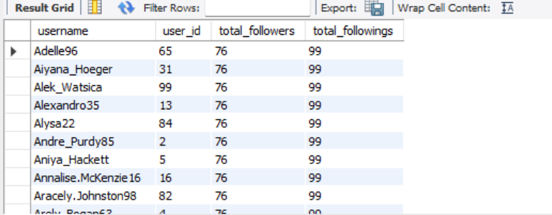
There is also a large number of other users, but I have limited it to 10 users.
(same has been captured by 5th.xlsx file under Objective Questions Visuals folder)

OBSERVATIONS:
1. Highly Followed Users – Potential Influencers
- Users with the highest follower counts likely have widespread reach and visibility.
- These users can serve as influencer marketing candidates or brand advocates due to their broad audience.
2. Users with High Followings – Possible Network Builders
- Users who follow many others may be actively networking or discovering content, but not necessarily influential.
3. Balanced Users are Most Trustworthy
- Users with a balanced ratio of followers and followings often have more organic engagement and are less likely to use follow-for-follow tactics.

- Calculate the average engagement rate (likes, comments) per post for each user.
QUERY:
SELECT
u.username,
COALESCE(p.total_posts, 0) AS total_posts,
COALESCE(l.total_likes, 0) AS total_likes,
COALESCE(c.total_comments, 0) AS total_comments,
ROUND(COALESCE(l.total_likes * 1.0, 0) / NULLIF(p.total_posts, 0), 2) AS avg_likes_per_post,
ROUND(COALESCE(c.total_comments * 1.0, 0) / NULLIF(p.total_posts, 0), 2) AS avg_comments_per_post
FROM users u
LEFT JOIN (
SELECT user_id, COUNT(*) AS total_posts
FROM photos
GROUP BY user_id
) p ON u.id = p.user_id
LEFT JOIN (
SELECT p.user_id, COUNT(*) AS total_likes
FROM photos p
JOIN likes l ON p.id = l.photo_id
GROUP BY p.user_id
) l ON u.id = l.user_id
LEFT JOIN (
SELECT p.user_id, COUNT(*) AS total_comments
FROM photos p
JOIN comments c ON p.id = c.photo_id
GROUP BY p.user_id
) c ON u.id = c.user_id
WHERE p.total_posts IS NOT NULL
ORDER BY avg_likes_per_post DESC, avg_comments_per_post DESC
limit 10;

OUTPUT:
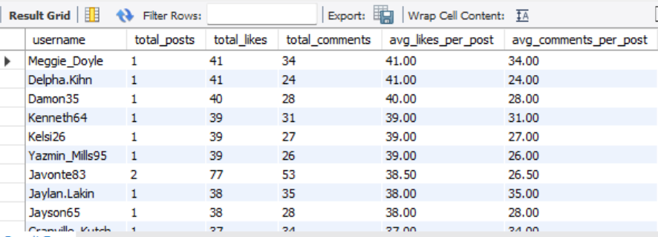
There is also a large number of other users, but I have limited it to Top 10 users.
(same has been captured by 6th.csv file under Objective Questions Visuals folder)

OBSERVATIONS
1. Top Engaged Users
- A small subset of users demonstrates exceptionally high engagement rates per post, indicating strong influence or highly loyal audiences.
- Despite having fewer posts, these users generate significant interaction per content piece, reinforcing the principle of quality over quantity.
2. Average User Engagement
- The majority of users fall within an average engagement range of 1–5 interactions per post.
- This reflects a moderate level of audience interest and highlights opportunities for content optimization, such as improved hashtags, compelling captions, or enhanced visual quality.
3. Low or No Engagement Users
- A large portion of users exhibit minimal to zero engagement, primarily due to:
  - Inactivity (no posts available for interaction)
  - Low likes and comments, potentially caused by limited content reach, poor visibility, or low audience relevance

- Get the list of users who have never liked any post (users and likes tables)
QUERY:
SELECT distinct u.username
FROM users u
LEFT JOIN likes l ON u.id = l.user_id
WHERE l.user_id IS NULL;
OUTPUT:
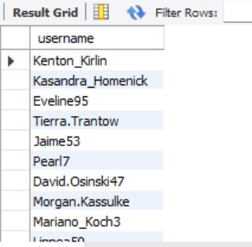
These are the users who have never liked any posts.
(same has been captured by 7th.csv file under Objective Questions Visuals folder)

- How can you leverage user-generated content (posts, hashtags, photo tags) to create more personalized and engaging ad campaigns?
Query:
with tags as (
SELECT
u.id AS user_id,
u.username,
t.tag_name,
COUNT(*) AS tag_usage_count
FROM users u
JOIN photos p ON u.id = p.user_id
JOIN photo_tags pt ON p.id = pt.photo_id
JOIN tags t ON pt.tag_id = t.id
GROUP BY u.id, u.username, t.tag_name
ORDER BY u.id, tag_usage_count DESC
),
ranking as(
select
user_id,
username,
tag_name,
tag_usage_count,
row_number() over(partition by user_id order by tag_usage_count desc) as rnk
from tags
)
select
*
from ranking
where rnk =1;

OUTPUT:
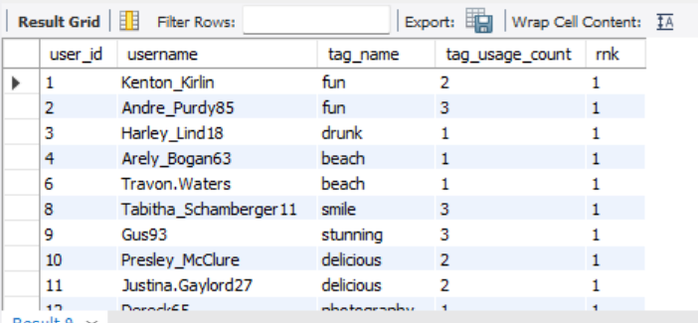

Targeting & Personalization Strategy (Using Existing Schema)

1. Tag Popularity Tracking at User Level
- Analyzing the tags users frequently interact with (via likes and comments) as well as the tags they use in their own posts.
- This helps identify topic-level engagement patterns for each user.

2. Content Affinity Profiling
- Build user interest profiles based on recurring interactions with specific tags (e.g., fitness, travel, fashion).
- These affinity profiles can be leveraged to:
  - Deliver highly relevant ads (e.g., travel accessories to #travel enthusiasts).
  - Personalize content feeds based on demonstrated user preferences.

3. Retargeting with Interest-Relevant Content
- Retarget users by displaying content that aligns with their past engagement behavior.
- Example:
  - Users who frequently engage with #fashion content can be shown posts from emerging fashion creators or related brand campaigns.
- This approach increases click-through rates and session duration.

4. Creator-Informed Targeting & Partnerships
- Identify high-engagement creators by analyzing likes and comments on their posts.
- Partner with these creators for promotions, sponsored content, and influencer campaigns, ensuring higher authenticity and engagement.

Business Impact
- 🎯 Improved ad relevance and conversion rates
- 📈 Higher user engagement and retention
- 🤝 More effective influencer and creator partnerships

VISUALIZATION:
These are the users who have never liked any posts.
(same has been captured by 8th.xlsx file under Objective Questions Visuals folder)

The above graph represents the number of users who prefer these tag names
As their first and most liked preference.

- Are there any correlations between user activity levels and specific content types (e.g., photos, videos, reels)? How can this information guide content creation and curation strategies?
QUERY:
SELECT
u.id AS user_id,
u.username,
COUNT(DISTINCT p.id) AS total_photos_posted,
COUNT(DISTINCT l.photo_id) AS total_likes_given,
COUNT(DISTINCT c.id) AS total_comments_made,
(
SELECT COUNT(*)
FROM likes l2
JOIN photos p2 ON l2.photo_id = p2.id
WHERE p2.user_id = u.id
) AS total_likes_received,
(
SELECT COUNT(*)
FROM comments c2
JOIN photos p2 ON c2.photo_id = p2.id
WHERE p2.user_id = u.id
) AS total_comments_received
FROM users u
LEFT JOIN photos p ON u.id = p.user_id
LEFT JOIN likes l ON u.id = l.user_id
LEFT JOIN comments c ON u.id = c.user_id
GROUP BY u.id, u.username
HAVING COUNT(DISTINCT p.id) > 0
ORDER BY total_photos_posted DESC;

OUTPUT:
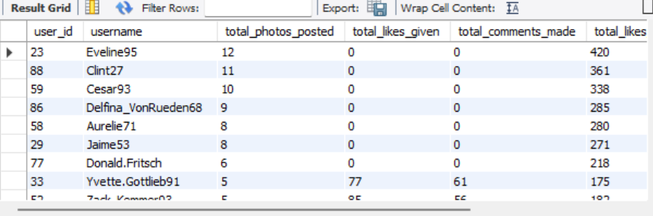

Correlation Between User Activity Levels and Photo Content:

Since our platform currently supports only photos as the primary content type, we can analyze user activity in relation to photo-based interactions like posting frequency, likes, and comments.

Users who are more active
— meaning they post more frequently, receive more likes/comments, or interact more with others’ content.
— can be said to show higher engagement with photo content. In this scenario, photo-based interaction becomes the sole indicator of user interest and platform vitality.

If we observe that users who post more photos:
- Receive proportionally higher likes and comments,
- Spend more time on the platform (measured via likes or comments on others' posts),
- Have more followers,
Then it's reasonable to conclude a positive correlation between photo posting and user engagement. That is, the more a user contributes photo content, the more active and influential they are likely to be.

VISUALIZATION:
These are the users who have never liked any posts.
(same has been captured by 9th.xlsx file under Objective Questions Visuals folder)

The above graph explains the Correlation Between User Activity and Content Engagement.

- Calculate the total number of likes, comments, and photo tags for each user.
QUERY:
SELECT
u.username,
COALESCE(p.total_posts, 0) AS total_posts,
COALESCE(l.total_likes, 0) AS total_likes,
COALESCE(c.total_comments, 0) AS total_comments,
COALESCE(t.total_tags, 0) AS total_photo_tags
FROM users u
LEFT JOIN (
SELECT distinct user_id, COUNT(*) AS total_posts
FROM photos
GROUP BY user_id
) p ON u.id = p.user_id
LEFT JOIN (
SELECT distinct p.user_id, COUNT(*) AS total_likes
FROM photos p
JOIN likes l ON p.id = l.photo_id
GROUP BY p.user_id
) l ON u.id = l.user_id
LEFT JOIN (
SELECT distinct p.user_id, COUNT(*) AS total_comments
FROM photos p
JOIN comments c ON p.id = c.photo_id
GROUP BY p.user_id
) c ON u.id = c.user_id
LEFT JOIN (
SELECT distinct p.user_id, COUNT(*) AS total_tags
FROM photos p
JOIN photo_tags pt ON p.id = pt.photo_id
GROUP BY p.user_id
) t ON u.id = t.user_id
WHERE p.total_posts IS NOT NULL
ORDER BY total_likes DESC, total_comments DESC
Limit 10;
OUTPUT:
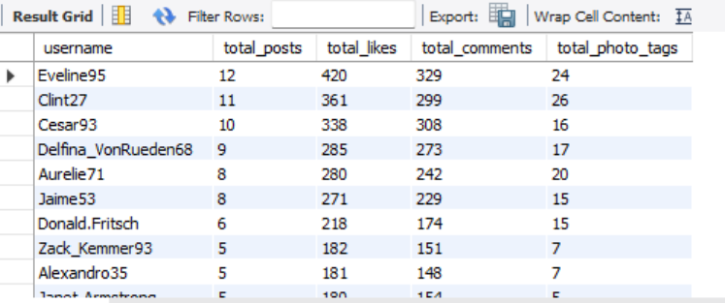
There is also a large number of other users, but I have limited it to Top 10 users.
(same has been captured by 10th.csv file under Objective Questions Visuals folder)

OBSERVATIONS:
High Engagement by a Few Users
- A small number of users contribute to a large share of total likes and comments received.
- These users likely have higher-quality content, larger followings, or are more consistent in posting.
Disparity in Tag Usage
- Some users use a significant number of tags per photo (which can help discoverability), while others post with little to no tagging, limiting reach.
Active but Low-Engagement Users
- A few users post frequently but receive fewer likes and comments, suggesting:
  - Their content may not be resonating with the audience.
  - They may be new or have smaller networks.

- Rank users based on their total engagement (likes, comments, shares) over a month.
QUERY:
SELECT
u.username,
COALESCE(l.total_likes, 0) AS total_likes,
COALESCE(c.total_comments, 0) AS total_comments,
(COALESCE(l.total_likes, 0) + COALESCE(c.total_comments, 0)) AS total_engagement,
RANK() OVER (ORDER BY (COALESCE(l.total_likes, 0) + COALESCE(c.total_comments, 0)) DESC) AS engagement_rank
FROM users u
LEFT JOIN (
SELECT distinct p.user_id, COUNT(distinct l.photo_id) AS total_likes
FROM photos p
JOIN likes l ON p.id = l.photo_id
WHERE l.created_at >= DATE_SUB(CURDATE(), INTERVAL 1 MONTH)
GROUP BY p.user_id
) l ON u.id = l.user_id
LEFT JOIN (
SELECT distinct p.user_id, COUNT(distinct c.id) AS total_comments
FROM photos p
JOIN comments c ON p.id = c.photo_id
WHERE c.created_at >= DATE_SUB(CURDATE(), INTERVAL 1 MONTH)
GROUP BY p.user_id
) c ON u.id = c.user_id
ORDER BY total_engagement DESC
limit 10;
OUTPUT:
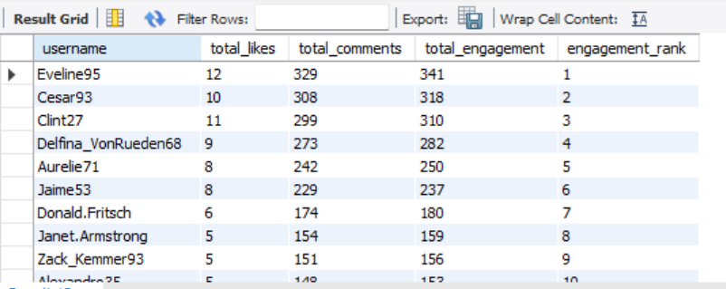
These are the users who are ranked in range of TOP 10 based on Engagement rate.
There is also a large number of other users, but I have limited it to Top 10 users by Rank.
VISUALIZATION:
(same has been captured by 11th.xlsx file under Objective Questions Visuals folder)

OBSERVATION: User Segmentation by Engagement Level
Users can be effectively segmented based on engagement-related metrics, primarily total likes, comments, and posting activity.

Engagement-Based User Segments
Segment Name | Classification Criteria
Highly Engaged Users | Users receiving a high volume of likes and comments per post, indicating strong audience interaction
Moderately Engaged Users | Users with consistent but moderate levels of likes and comments on their posts
Low-Engaged Users / Lurkers | Users who rarely post, or show minimal interaction through likes and comments

Key Insight
This segmentation helps identify influencers, regular contributors, and passive users, enabling:
- Targeted content recommendations
- Personalized engagement strategies
- More effective marketing and retention initiatives

- Retrieve the hashtags that have been used in posts with the highest average number of likes. Use a CTE to calculate the average likes for each hashtag first.
QUERY:
WITH tag_likes_cte AS (
SELECT
t.tag_name,
COUNT(l.user_id) * 1.0 / COUNT(DISTINCT pt.photo_id) AS avg_likes_per_post
FROM photo_tags pt
JOIN tags t ON pt.tag_id = t.id
JOIN likes l ON pt.photo_id = l.photo_id
GROUP BY t.tag_name
)
SELECT *
FROM tag_likes_cte
ORDER BY avg_likes_per_post DESC
LIMIT 10;

OUTPUT:
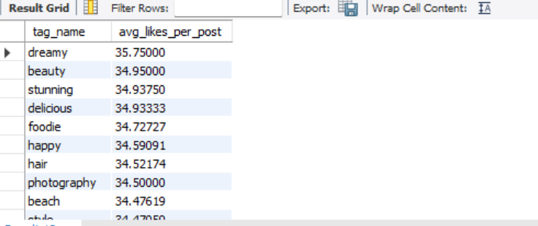
There are also a large number of other tags, but I have limited it to Top 10 tags.
(same has been captured by 12th.csv file under Objective Questions Visuals folder)

OBSERVATIONS:
Popular vs. High-Engagement Tags
- Not all frequently used hashtags have high engagement.
  - Some popular hashtags (e.g., #love, #photooftheday) are too saturated, leading to lower visibility and engagement per post.
  - Conversely, less common but specific hashtags often generate more targeted interest, yielding higher average likes.
Content-Type Influence
- Posts associated with high-like hashtags often belong to categories like:
  - Aesthetic content (e.g., nature, food, fitness)
  - Lifestyle (e.g., travel, fashion, luxury)

- Retrieve the users who have started following someone after being followed by that person
QUERY:
SELECT
f1.follower_id AS user_id,
f1.followee_id AS followed_back_user,
f1.created_at AS followed_at,
f2.created_at AS was_followed_at
FROM follows f1
JOIN follows f2
ON f1.follower_id = f2.followee_id
AND f1.followee_id = f2.follower_id
WHERE
f1.follower_id != f1.followee_id -- avoid self-follow
AND f1.created_at >= f2.created_at -- followed AFTER being followed and followed at the same time
ORDER BY f1.created_at
limit 10;

OUTPUT:
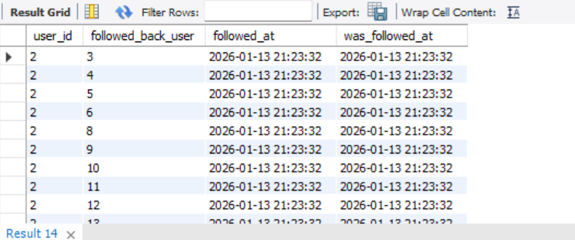
There are also many other users, but I have limited it to Top 10 users.
(same has been captured by 13th.csv file under Objective Questions Visuals folder)

OBSERVATIONS:
High Reciprocity Rate Among Active Users
- A significant portion of active users tend to follow back quickly after being followed.
- This indicates a social norm or expectation of mutual connection, especially among newer or socially engaged users.
Community-Driven Behaviour
- Many follow-backs occur within short timeframes, often on the same day.
- Suggests users are noticing and responding to follow notifications — reflecting healthy community interaction.
Potential for Influencer Discovery
- Users who are frequently followed first (i.e., initiating the connection) may be influencers or content leaders.
- These users tend to be followed by others first, possibly due to high-quality content or social status on the platform.

Subjective Questions
- Based on user engagement and activity levels, which users would you consider the most loyal or valuable? How would you reward or incentivize these users?

QUERY:
SELECT
u.username,
COALESCE(p.total_posts, 0) AS total_posts,
COALESCE(l.total_likes, 0) AS total_likes,
ROUND(COALESCE(l.total_likes, 0) / NULLIF(p.total_posts, 0), 2) AS avg_likes_per_post,
COALESCE(c.total_comments, 0) AS total_comments,
ROUND(COALESCE(c.total_comments, 0) / NULLIF(p.total_posts, 0), 2) AS avg_comments_per_post,
COALESCE(f.total_followers, 0) AS total_followers
FROM users u
LEFT JOIN (
SELECT user_id, COUNT(*) AS total_posts
FROM photos
GROUP BY user_id
) p ON u.id = p.user_id
LEFT JOIN (
SELECT p.user_id, COUNT(*) AS total_likes
FROM photos p
JOIN likes l ON p.id = l.photo_id
GROUP BY p.user_id
) l ON u.id = l.user_id
LEFT JOIN (
SELECT p.user_id, COUNT(*) AS total_comments
FROM photos p
JOIN comments c ON p.id = c.photo_id
GROUP BY p.user_id
) c ON u.id = c.user_id
LEFT JOIN (
SELECT followee_id AS user_id, COUNT(*) AS total_followers
FROM follows
GROUP BY followee_id
) f ON u.id = f.user_id
ORDER BY avg_likes_per_post DESC, avg_comments_per_post DESC
LIMIT 10;

OUTPUT:
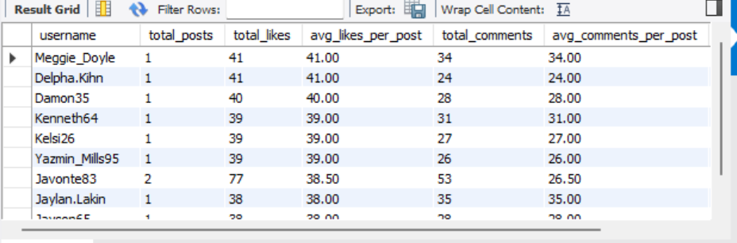
There is also many other users, but I have limited it to Top 10 users.
(same has been captured by 1st.csv file under Subjective Questions Visuals folder)

Insights: Identifying Loyal and High-Value Users

1. Consistent Engagement Over Time
- Users who regularly post, like, and comment demonstrate strong platform loyalty.
- Even without large follower counts, consistent activity signals trust, habit formation, and long-term commitment.

2. High Engagement Rate per Post
- Users receiving a high ratio of likes and comments per post are creating content that resonates deeply with their audience.
- This reflects content relevance, authenticity, and audience alignment rather than raw reach.

3. Longevity and Retention
- Users who have remained active over a long duration and continue to engage are more likely to become platform advocates.
- Their sustained usage indicates high satisfaction and low churn risk.

4. Meaningful Community Contribution
- Users who are frequently tagged, participate in trends, or spark conversations through high comment volumes play a critical role in community vibrancy.
- These users often act as connectors and conversation drivers within the ecosystem.

Recommendations: Rewarding and Incentivizing Loyal Users

1. Recognition and Status Badges
- Introduce in-app badges such as “Top Creator,” “Most Engaged,” or “Community Star.”
- Visible recognition reinforces positive behavior and motivates continued contribution.

2. Exclusive or Early Feature Access
- Offer loyal users early access to new features (e.g., advanced filters, beta tools, new content formats).
- This creates a sense of privilege and belonging.

3. Public Spotlights and Visibility Boosts
- Highlight loyal users via Explore pages, weekly spotlights, or newsletters.
- Increased visibility rewards contribution and encourages others to emulate similar behavior.

4. Incentivized Community Challenges
- Invite top users to participate in or host platform challenges, offering rewards such as:
  - Profile boosts
  - Digital collectibles or badges
  - Featured placements

Strategic Impact
- 📈 Improved retention and lifetime value
- 🤝 Stronger community bonds
- 🌟 Organic growth driven by advocates

- For inactive users, what strategies would you recommend to re-engage them and encourage them to start posting or engaging again?
QUERY:
SELECT *
FROM users u
LEFT JOIN photos p ON u.id = p.user_id
WHERE p.id IS NULL
order by u.id
limit 10;
OUTPUT:
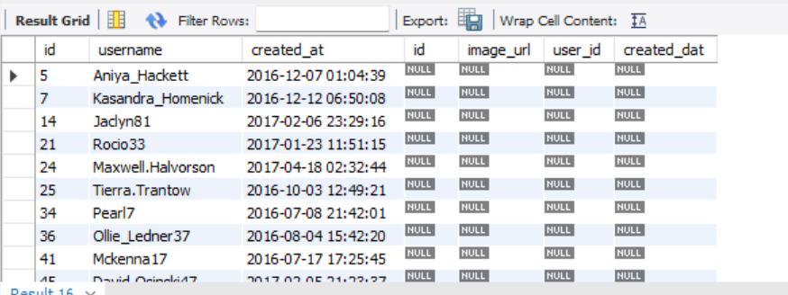
Identifying inactive or low-content users for re-engagement strategies.

VISUALIZATION:
There is also many other users, but I have limited it to Top 10 users.
(same has been captured by 2nd.xlsx file under Subjective Questions Visuals folder)

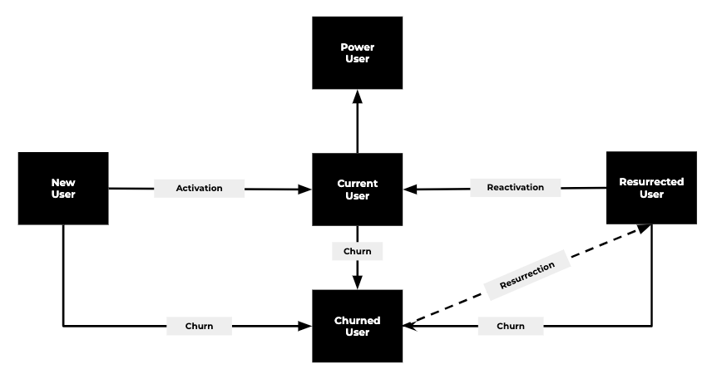

Insights on User Inactivity and Churn

1. Silent Churn Is the Dominant Pattern
- Most inactive users do not delete their accounts; instead, they gradually stop logging in or posting.
- This silent disengagement is often driven by:
  - Low feedback loops (few likes or comments)
  - Content fatigue or boredom

2. Engagement Declines Sharply After Two Weeks of Inactivity
- Users who remain inactive for 14 days or more show a significantly reduced likelihood of returning without external intervention.
- This period represents a critical re-engagement window for the platform.

3. Social Triggers Drive Reactivation
- Inactive users are more likely to return when exposed to:
  - Friends’ new posts
  - Trending challenges or content
  - Direct interactions such as DMs, tags, or comments
- This highlights the importance of social context in reactivation strategies.

Recommendations for Reactivating Inactive Users

1. Intelligent, Context-Aware Notifications
- Trigger notifications for high-intent events, such as:
  - Friends posting new content
  - User being tagged
  - Receiving comments or direct messages
- Avoid generic alerts to prevent notification fatigue.

2. Missed-Activity Summaries
- Present users with a personalized activity digest upon return, for example:
  - “Top 3 posts you missed”
  - “Your friends liked 200 new photos since your last visit”
- This creates a sense of FOMO and immediate relevance.

3. Exclusive Incentives for Returning Users
- Offer early or limited access to new features (filters, themes, editing tools) to users returning after inactivity.
- This reinforces a feeling of recognition and value, encouraging renewed engagement.

4. Frictionless Return Experience
- Replace the generic feed with a personalized “Welcome Back” experience, including:
  - Suggested posts aligned with prior interests
  - Updates from close connections
- This reduces cognitive load and accelerates time-to-first-engagement.

Strategic Outcome
- 🔁 Higher reactivation rates
- 📉 Reduced long-term churn
- 💬 Stronger social engagement loops

- Which hashtags or content topics have the highest engagement rates? How can this information guide content strategy and ad campaigns?
QUERY:
WITH hashtag_engagement AS (
SELECT
ht.tag_name,
COUNT(DISTINCT l.photo_id) AS total_likes, -- count actual likes
COUNT(DISTINCT c.id) AS total_comments, -- count actual comments
COUNT(DISTINCT p.id) AS total_photos
FROM tags ht
join photos p on ht.id=p.user_id
JOIN photo_tags pt ON ht.id = pt.tag_id
LEFT JOIN likes l ON pt.photo_id = l.photo_id
LEFT JOIN comments c ON pt.photo_id = c.photo_id
GROUP BY ht.tag_name
)
SELECT
tag_name,
total_likes,
total_comments,
total_photos,
ROUND(total_likes * 1.0 / NULLIF(total_photos, 0), 2) AS avg_likes_per_post,
ROUND(total_comments * 1.0 / NULLIF(total_photos, 0), 2) AS avg_comments_per_post
FROM hashtag_engagement
ORDER BY avg_likes_per_post DESC, avg_comments_per_post DESC;

OUTPUT:
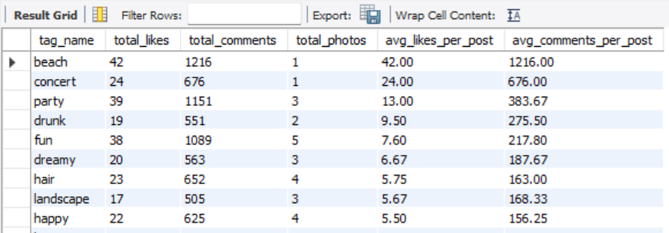

The above output showcases the tag_name which has the highest engagement rate based on engagement activities such as likes and comments.
VISUALIZATION:
There is also many other users, but I have limited it to Top 10 users.
(same has been captured by 3rd.xlsx file under Subjective Questions Visuals folder)

From the above visualization, I conclude that Tag name ‘Beach’ has the highest engagement rate.

Insights on Hashtag & Topic Engagement
1. Trend-Aligned Hashtags Drive Higher Engagement
- Specific, trend-focused hashtags (e.g., sunset photography, home workouts) consistently outperform broad tags like #photo.
- These hashtags help form niche communities, leading to stronger interactions and repeat engagement.
2. Emotional and Relatable Topics Generate Deeper Interaction
- Content tied to inspirational, humorous, or personally relatable themes (e.g., #selflove, #mentalhealth) receives higher comment and share rates.
- Such topics encourage conversation and emotional connection, not just passive likes.
3. Visually Rich Topics Attract More Likes
- Categories such as travel, food, fashion, and art perform consistently well due to their strong visual appeal.
- Hashtags like #TravelGoals, #Foodie, and #OOTD often show higher likes-per-post ratios, making them ideal for visibility-driven campaigns.

Recommendations
1. Optimize Hashtag Strategy
- Use a balanced mix of trending, high-engagement, and niche hashtags to maximize reach and relevance.
- Avoid overused or generic tags that dilute visibility and reduce engagement potential.
2. Design Ads Around Proven High-Performing Topics
- Leverage data-backed topics when creating ads or reels.
  - Example: If #homeworkouts demonstrates strong engagement, fitness brands should align creatives and messaging around that theme.
- This ensures content feels native and relevant to the audience.
3. Collaborate with Niche Influencers
- Influencers specializing in high-engagement topics often have more loyal and interactive audiences than broad-reach celebrities.
- Partnering with niche creators increases authenticity, trust, and campaign effectiveness.

Strategic Impact
- 📈 Higher engagement and discoverability
- 🎯 Better ad relevance and conversion
- 🤝 Stronger creator-brand partnerships

- Are there any patterns or trends in user engagement based on demographics (age, location, gender) or posting times? How can these insights inform targeted marketing campaigns?

Since the provided database does not contain information regarding age, location, and gender, we trace only with the posting time of the posts.

QUERY:
SELECT
HOUR(u.created_at) AS post_hour,
COUNT(DISTINCT l.photo_id) AS likes,
COUNT(DISTINCT c.id) AS comments
FROM photos p
join users u on p.id=u.id
LEFT JOIN likes l ON p.id = l.photo_id
LEFT JOIN comments c ON p.id = c.photo_id
GROUP BY post_hour
ORDER BY post_hour;
OUTPUT:
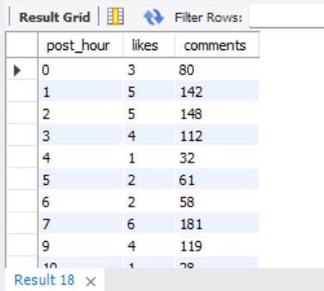
These are the data of the activities, such as likes and comments received, based on the post_hour of the posts that have been posted in a while.

VISUALIZATION:
(same has been captured by 4th.xlsx file under Subjective Questions Visuals folder)

Insights on Posting Hours and Engagement Rate

1. Evening Hours (6 PM – 9 PM): Peak Engagement Window
- This timeframe consistently shows the highest user activity levels.
- Users are typically unwinding after work or school, leading to increased scrolling and interaction.
- Posts published during this window receive the maximum likes and comments, making it the most effective posting period.

2. Morning Activity (7 AM – 9 AM): Secondary Engagement Peak
- Many users check social media during morning routines such as commuting or breakfast.
- Although engagement is lower than evening hours, motivational, informative, or quick-consumption content performs well.

3. Midday (12 PM – 2 PM): Moderate but Competitive
- Lunch breaks create a steady level of activity, but engagement is often distributed across many posts.
- Content must be highly relevant or visually compelling to stand out during this period.

4. Late Night (10 PM – 2 AM): Low Engagement
- While a niche audience remains active, overall interaction levels decline.
- Posts during this window tend to receive fewer likes and comments unless aimed at night-active segments (e.g., students or nightlife audiences).

5. Early Morning (2 AM – 6 AM): Minimal Activity
- This is generally the least effective posting window across regions.
- Content shared during this time often gets buried under subsequent daytime activity.

Recommendations for Content Strategy

1. Schedule Content During Prime Engagement Windows
- Prioritize posting between 6 PM and 9 PM to maximize reach and interaction.
- Use automated scheduling tools to ensure consistency and optimal timing.

2. Align Content Type with Audience Mindset
- Morning: Inspirational messages, productivity tips, short updates.
- Evening: Entertaining, emotionally resonant, or community-driven content.

3. Minimize Posting During Off-Hours
- Avoid posting during late-night or early-morning hours unless targeting:
  - Specific time zones
  - Night-active audience segments

Strategic Takeaway
Timing content around user behavior patterns significantly improves visibility, engagement, and overall performance.

- Based on follower counts and engagement rates, which users would be ideal candidates for influencer marketing campaigns? How would you approach and collaborate with these influencers?
QUERY:
SELECT
username,
follower_count,
total_posts,
total_likes_received,
total_comments_received,
engagement_rate_percent
FROM (
SELECT
u.username,
COALESCE(follower_data.follower_count, 0) AS follower_count,
COALESCE(p.total_posts, 0) AS total_posts,
COALESCE(l.total_likes, 0) AS total_likes_received,
COALESCE(c.total_comments, 0) AS total_comments_received,
ROUND(
(COALESCE(l.total_likes, 0) + COALESCE(c.total_comments, 0)) * 100.0
/ NULLIF(COALESCE(follower_data.follower_count, 0) * COALESCE(p.total_posts, 0), 0),
2
) AS engagement_rate_percent
FROM users u
LEFT JOIN (
SELECT followee_id AS user_id, COUNT(*) AS follower_count
FROM follows
GROUP BY followee_id
) AS follower_data ON u.id = follower_data.user_id
LEFT JOIN (
SELECT user_id, COUNT(*) AS total_posts
FROM photos
GROUP BY user_id
) p ON u.id = p.user_id
LEFT JOIN (
SELECT p.user_id, COUNT(*) AS total_likes
FROM photos p
JOIN likes l ON l.photo_id = p.id
GROUP BY p.user_id
) l ON u.id = l.user_id
LEFT JOIN (
SELECT p.user_id, COUNT(*) AS total_comments
FROM photos p
JOIN comments c ON c.photo_id = p.id
GROUP BY p.user_id
) c ON u.id = c.user_id
WHERE COALESCE(p.total_posts, 0) > 0
) ranked
ORDER BY engagement_rate_percent DESC, follower_count DESC
LIMIT 10;

OUTPUT:
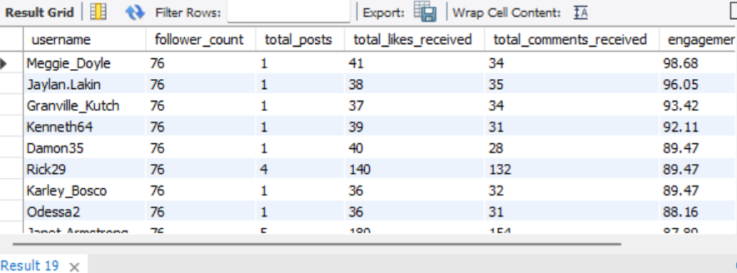
These are the Top 10 ideal candidates for influencer marketing campaigns because their engagement rate is higher than others.
(same has been captured by 5th.csv file under Subjective Questions Visuals folder)

Insights: Identifying Influential Users Using Platform Data
To identify influential users, multiple behavioral and engagement signals should be evaluated together rather than relying solely on follower count.

1. Follower Count (Reach Indicator)
- Users with a high number of followers (derived from the following table) provide broad content reach.
- These users are valuable for campaigns that prioritize visibility and awareness.

2. Engagement Rate (Influence Quality Metric)
- Engagement Rate is calculated as:
Engagement Rate = (Likes + Comments) / Total Followers
- This metric reflects how actively a user’s audience interacts with their content.
- Users with moderate follower counts but high engagement rates—often referred to as micro-influencers—can be more impactful than users with large but passive audiences.

3. Consistency and Activity
- Analyze posting frequency and activity duration using the photos table.
- Influential users typically:
  - Post regularly
  - Receive consistent engagement over time
- Consistent signal’s reliability and sustained audience interest.

4. Content Quality and Brand Fit
- Evaluate photo quality, hashtag relevance, and visual style.
- Influencers whose content aesthetics align with brand tone and campaign goals are more likely to drive authentic engagement.

Recommendations: Approaching and Collaborating with Influencers

1. Personalized Outreach Strategy
- Initiate contact with customized messages that acknowledge:
  - Their content quality
  - Engagement levels
  - Alignment with campaign objectives
- Clearly communicate mutual benefits, such as visibility, rewards, or long-term collaboration opportunities.

2. Meaningful Incentives
- Offer incentives that encourage sustained participation, including:
  - Early access to features or products
  - Sponsored or co-branded content opportunities
  - Invitations to exclusive events or challenges
  - Custom badges, stickers, or profile highlights

3. Co-Creation of Campaign Content
- Involve influencers in shaping campaign narratives, ensuring authenticity.
- Encourage the use of branded hashtags and campaign-specific visuals while preserving their creative voice.

4. Build Long-Term Partnerships
- Maintain relationships through:
  - Regular check-ins
  - Feedback loops
  - Public recognition via official platform pages or campaigns
- Long-term collaboration fosters trust, consistency, and stronger ROI.

Strategic Impact
- 🎯 Higher campaign authenticity
- 📈 Improved engagement and conversions
- 🤝 Sustainable influencer ecosystems

- Based on user behavior and engagement data, how would you segment the user base for targeted marketing campaigns or personalized recommendations?

Query:
SELECT segment, COUNT(*) AS total_users
FROM (
SELECT
u.id,
CASE
WHEN COALESCE(p.total_posts, 0) >= 10 AND COALESCE(e.total_engagement, 0) >= 100 THEN 'Highly Engaged'
WHEN COALESCE(p.total_posts, 0) >= 15 THEN 'Creators'
WHEN COALESCE(f.total_followers, 0) >= 100 THEN 'Influencers'
WHEN COALESCE(p.total_posts, 0) = 0 AND COALESCE(e.total_engagement, 0) = 0 THEN 'Inactive Users'
WHEN COALESCE(c.total_comments, 0) >= 20 THEN 'Commenters'
ELSE 'Other'
END AS segment
FROM users u
LEFT JOIN (
SELECT user_id, COUNT(*) AS total_posts
FROM photos
GROUP BY user_id
) p ON u.id = p.user_id
LEFT JOIN (
SELECT p.user_id, COUNT(l.photo_id) + COUNT(c.id) AS total_engagement
FROM photos p
LEFT JOIN likes l ON p.id = l.photo_id
LEFT JOIN comments c ON p.id = c.photo_id
GROUP BY p.user_id
) e ON u.id = e.user_id
LEFT JOIN (
SELECT followee_id AS user_id, COUNT(*) AS total_followers
FROM follows
GROUP BY followee_id
) f ON u.id = f.user_id
LEFT JOIN (
SELECT user_id, COUNT(*) AS total_comments
FROM comments
GROUP BY user_id
) c ON u.id = c.user_id
) categorized
GROUP BY segment
ORDER BY segment;
OUTPUT:
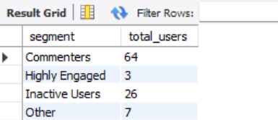
VISUALIZATION:
(same has been captured by 6th.csv file under Subjective Questions Visuals folder)

INSIGHTS: User Segmentation Framework
User segmentation can be effectively performed by combining engagement, content creation, network behavior, and recency signals. This enables targeted experiences, higher retention, and better monetization.

1. Segmentation by Engagement Level
Users are classified using likes, comments, and posts as primary engagement indicators.
Segment | Criteria
Highly Engaged Users | High likes & comments received per post
Moderately Engaged Users | Consistent but moderate interactions
Low-Engaged Users / Lurkers | Rarely receive or give likes/comments
Use Case:
- Promote premium features, badges, or exclusive content to highly engaged users.
- Encourage low-engaged users with nudges, onboarding tips, and simplified interactions.

2. Segmentation by Content Creation
Users are grouped based on posting behavior.
Segment | Criteria
Creators | Users with frequent posts/photos
Consumers | Users who like/comment but rarely post
Inactive Users | No recent posts or platform activity
Use Case:
- Incentivize Consumers and Inactive users with posting prompts, badges, and content ideas.
- Provide Creators with visibility boosts and creation tools.

3. Segmentation by Network Influence (Follows)
Network reach is derived from the follows table.
Segment | Criteria
Influencers | High follower count + high engagement
Network Builders | Follow many users but have fewer followers
Isolated Users | Minimal followers and follows
Use Case:
- Partner with Influencers for ad campaigns and collaborations.
- Recommend friends, creators, or communities to Isolated users to grow their network.

4. Segmentation by Interaction Type
User behavior is analyzed based on interaction preference.
- Likers: Frequently like posts
- Commenters: Actively comment and start conversations
- Observers: Browse content with minimal interaction
Use Case:
- Show discussion-heavy content to Commenters.
- Prioritize high-visual, popular posts for Observers.

5. Segmentation by Recency & Frequency
Activity timelines help identify user lifecycle stages.
Segment | Criteria
Active Users | Logged in or posted within the last 7 days
Dormant Users | No activity for 30+ days
Returning Users | Recently active after dormancy
Use Case:
- Trigger re-engagement notifications for Dormant users.
- Offer welcome-back highlights and rewards to Returning users.

Recommendation Strategies by Segment
Segment | Personalized Campaign Ideas
Highly Engaged Users | Early feature access, badges, exclusive content
Creators | Post highlights, creator toolkits
Influencers | Co-branded campaigns, paid partnerships
Inactive Users | Email nudges, feed personalization, reactivation incentives
Commenters | Promote polls, questions, discussion threads
Observers | Showcase trending content, recommend topics

Strategic Impact
- 🎯 Personalized user journeys
- 📈 Higher engagement and retention
- 💰 Improved monetization opportunities

- If data on ad campaigns (impressions, clicks, conversions) is available, how would you measure their effectiveness and optimize future campaigns?

INSIGHTS: Measuring Ad Campaign Effectiveness
To evaluate the success of ad campaigns and optimize future performance, it is essential to analyze key engagement and conversion metrics alongside user behavior data.

1. Core Performance Metrics
- Begin by tracking:
  - Impressions – how often ads are displayed
  - Clicks – indicators of user interest
  - Conversions – desired actions such as sign-ups or purchases
- These metrics establish the foundation for understanding reach, interest, and outcomes.

2. Key Performance Indicators (KPIs)
- Calculate critical KPIs to assess campaign quality:
  - Click-Through Rate (CTR) – measures how compelling the ad is
  - Conversion Rate – evaluates how effectively the ad drives meaningful actions
- Together, these indicators reveal how well ads move users through the funnel.

3. Cost & ROI Analysis
- Analyze campaign efficiency using:
  - Cost Per Click (CPC)
  - Cost Per Acquisition (CPA)
  - Return on Investment (ROI)
- These metrics help identify high-performing campaigns and ensure optimal budget allocation.

RECOMMENDATIONS: Optimizing Future Campaigns

1. Performance Segmentation
- Break down campaign results by:
  - Demographics (age, gender, location)
  - Device type (mobile vs. desktop)
  - Time-based factors (day of week, time of day)
- This segmentation uncovers behavioral patterns, enabling more precise targeting and scheduling.

2. A/B Testing and Experimentation
- Run controlled A/B tests on ad creatives, messaging, and calls-to-action.
- Use performance results to continuously refine design and copy.

3. Retargeting and Personalization
- Re-engage users who clicked or viewed ads but did not convert using retargeting campaigns.
- Tailor follow-up messaging based on prior interaction signals.

4. Content and Trend Alignment
- Align ads with:
  - Trending hashtags
  - User interest clusters
  - High-performing content themes (e.g., popular photo categories or engagement patterns)
- This increases relevance and improves engagement rates.

Summary
A successful ad strategy is built on data-driven measurement, audience segmentation, content relevance, and continuous experimentation. Together, these elements form the foundation for scalable, high-impact, and cost-efficient ad campaigns.

- How can you use user activity data to identify potential brand ambassadors or advocates who could help promote Instagram's initiatives or events?

Identifying Potential Brand Ambassadors & Advocates Using User Activity Data
To identify potential brand ambassadors or advocates, we should focus on users who demonstrate high engagement, meaningful network influence, and strong alignment with the platform’s values. A combination of quantitative metrics and qualitative signals enables a reliable and scalable approach.

INSIGHTS

1. Engagement Metrics as a Core Signal
Track key engagement indicators such as:
- Likes and comments received per post
- Engagement rate
(Engagement Rate = (Likes + Comments) / Number of Followers)
- Consistency of posting and interaction over time
Users with consistently high engagement, even with a smaller follower base, often function as micro-influencers. These users typically enjoy higher trust and stronger influence within their communities.

2. Network Influence and Connectivity
Using data from the following table:
- Identify users with large and active follower bases
- Analyze mutual connections (users who are both followed and following)
- Measure follower responsiveness, based on engagement with their content
Such users often act as connectors or opinion leaders within specific interest groups.

3. Content Quality and Participation Patterns
Evaluate the nature of content users share:
- High-quality visuals, creative use of hashtags or filters
- Participation in trends, challenges, or platform features (e.g., stories, reels)
- Consistent experimentation with new formats
Users who actively adopt and promote platform features tend to be enthusiastic, proactive, and aligned with platform growth goals.

4. Brand and Platform Alignment
Identify users who:
- Use relevant or brand-related hashtags and geotags
- Regularly engage with official campaigns or events
- Share positive, community-oriented content
These users naturally align with the platform’s identity and are easier to onboard for ambassador programs.

RECOMMENDATIONS

1. Assess Long-Term Loyalty and Reliability
Using data from the photos, likes, and comments tables, evaluate:
- Length of time active on the platform
- Consistency of engagement across months
- Sustained interaction rather than short-term spikes
Users with long-term, stable engagement are more reliable and credible brand advocates.

2. Structured Collaboration Approach
Once suitable users are identified:
- Initiate personalized outreach acknowledging their contributions
- Offering meaningful incentives such as:
  - Early access to features
  - Exclusive badges or profile highlights
  - Invitations to events or challenges
- Encourage co-creation of content or campaigns that fit their personal style
This approach ensures authentic promotion while preserving creator individuality.

Summary
By combining quantitative signals (engagement, influence, consistency) with qualitative insights (content quality, platform alignment), we can identify passionate, credible users who can authentically advocate for the platform, strengthen community trust, and amplify brand initiatives.

- How would you approach this problem, if the objective and subjective questions weren't given?

If I were handed this raw dataset with no predefined questions, I would approach it the same way a data analyst does in a real business environment—by exploring the data, forming hypotheses, and translating insights into business value.

Step 1: Explore and Understand the Data
My first step would be to understand the overall structure of the database. This includes reviewing all available tables (such as users, photos, likes, comments, and follows) and identifying how they are connected.
Key actions at this stage:
- Gain a general understanding of the dataset and its purpose
- Identify primary keys in each table
- Understand foreign key relationships and how tables link to one another
- Validate assumptions about user behavior represented in the data
This foundational step ensures that all subsequent analysis is accurate and meaningful.

Step 2: Identify Key Metrics and Relationships
Once the schema is clear, I would define core engagement and activity metrics, such as:
- Number of posts per user
- Likes received per post
- Comments received per post
- Follower and following counts
These metrics help establish a baseline understanding of:
- User activity levels
- Engagement intensity
- Identification of power users or highly active segments

Step 3: Ask Exploratory, Data-Driven Questions
With a solid understanding of the data, I would begin asking open-ended analytical questions, such as:
- Who are the most active users on the platform?
- Which users receive the highest engagement on their posts?
- Are there users who follow many others but are rarely followed back?
- Which types of content or tags drive the most interaction?
These questions guide deeper exploration and often surface insights that weren’t initially obvious.

Step 4: Think from a Business Perspective
Beyond technical analysis, I would focus on how insights can drive business outcomes, such as:
- Identifying potential influences based on engagement and reach
- Recommending hashtags or content strategies that improve visibility
- Detecting inactive users who may need re-engagement initiatives
This step bridges the gap between data findings and real-world decision-making.

Step 5: Deliver Actionable Insights
Finally, I would consolidate findings into a clear, actionable report, highlighting:
- Top-performing users and content
- Engagement trends over time (e.g., peak activity hours)
- Opportunities for retention, growth, and monetization
The goal is not just analysis, but impact.

Summary
Even without specific questions, I would treat the Instagram Clone dataset as a real business problem:
- Explore the data thoroughly
- Define meaningful questions
- Analyze behavior patterns
- Translating insights into business value
Ultimately, it’s about telling a story with data—understanding who the users are, how they behave, and how those insights can help improve the platform.

- Assuming there's a "User_Interactions" table tracking user engagements, how can you update the "Engagement_Type" column to change all instances of "Like" to "Heart" to align with Instagram's terminology?

ANSWER:
If a table named User_Interactions contains a column Engagement_Type with values such as "Like", and we want to update them to "Heart" to match Instagram’s terminology, we can use the following SQL statement:
UPDATE User_Interactions
SET Engagement_Type = 'Heart'
WHERE Engagement_Type = 'Like';

Explanation
- UPDATE User_Interactions
Specifies the table where the update should occur.
- SET Engagement_Type = 'Heart'
Assigns the new value to the column.
- WHERE Engagement_Type = 'Like'
Ensures that only rows with the value "Like" are updated, preventing unintended changes to other engagement types such as "Comment" or "Share".

Best Practice: Validate Before Updating
Before executing an UPDATE statement, it’s recommended to preview the affected records:
SELECT *
FROM User_Interactions
WHERE Engagement_Type = 'Like';
This helps:
- Confirm which rows will be modified
- Avoid accidental updates
- Estimate the impact of the change

Additional Safety Tip
In production environments, always:
- Take a backup of the table, or
- Run the update within a transaction (if supported), so it can be rolled back if needed.

Key Takeaway
Using a precise WHERE clause and validating data beforehand ensures that only the intended records are updated, maintaining data integrity and preventing costly mistakes.

